Housekeeping:
Earlier this week, Gina, who is unfortunately unable to join us for this meeting, requested that I bring to the Board and investigate the situation about the future “opt-out” fees, and whether disabilities and accessibilities services will be part of that “opt-out” fee. Diane got back to me today and explained that students in the conjoint programs will not be affected by the opt-out program, with regards to Accessibility Services. What could be affected (and at this time she still has not received from UofT the final list of programs/services that will be considered “opt-out”) are the services offered through STUDENT LIFE FEES, which would not be applicable to any of our conjoint students, because we do not pay such fees.
Area Reps report:

Area and Rep’s Name | Content of report:
Biblical - Deborah
Pastoral - Beth Anne | I’ve received a list of our pastoral students from Amy and will contact them to let them know I’m the rep and see about a summer get together.
Systematics - Ethan
Historical - M.J.
Contextual - N/A
DMin - Barbara | No new updates
MA - N/A
ThM - N/A

College Reps’ Report:

College and Rep’s name | Content of Report:
Emmanuel - Gina
Knox - Mike A. | As of this point, Knox has only 3 grad courses (5000 or 6000) running all of next year. Combined with the fact that Knox has no grad student union/council, not much going on at Knox for grad students.  Dr. Luke Powery, Dean of Chapel and professor of homiletics at Duke, will be giving a lecture on convocation day, May 8, 10:00 a.m. at Knox. The lecture is open to all who wish to attend (but need to register at knox.college@utoronto.ca).
Regis - Mike R. | Regis Elected new Student Council Co-Presidents, both Basic Degree students, and the new Dean, Sr. Susan Wood will start at Regis on August 1. She is currently the chair of theology at Marquette. Otherwise, all’s well that ends well. Also Regis is finding ways to celebrate its 90th anniversary and is thinking about how to celebrate TST’s 50th.
St. Mikes - N/A
Trinity - Robbie
Wycliffe - Carolyn | Wycliffe is in the process of hiring a new faculty position for New Testament studies. AD students have had the opportunity to meet with each candidate.  The annual Scripture & Theology Colloquium is being held on May 9. All are welcome. There may be a fee, but I’m not sure yet.

VP-Academic’s report

Academic Council — Monday, March 25th, 2019

UTQAP (University of Toronto Quality Assurance Process)
- The review will take place in March 2020. This means that the self-evaluation will need to be finalized in Fall 2019.

Post-Doctoral Fellowship in Christian-Jewish Relations
- No new details

ThD Closure
- TST will be in direct communication with all students and their colleges. All students will be reviewed individually.
- The target date for completion is August 2023.
- All final requirements (i.e. coursework, proposals, and examinations) must be completed.
- Students may defend their dissertations after the deadline.
- TST will continue to hear individual petitions.

Curriculum Committee
- There was discussion that courses throughout TST need to be reviewed.

Faculty Assembly
- There was discussion that TST needs to be more interdisciplinary and be more collaborative with various concentrations.

Admissions
- In the first round, there were 51 offers of admission for Fall of 2019.
- 30+ applications were declined.
- Domestic enrollment was low for this year.
- There will be a second round of admissions this week (week of April 8th).

DMin
- Handbook: The DMin handbook for 2019-2020 was approved.
- Orientation: April 29th—May 3rd

NAIITS: An Indigenous Learning Community
(formerly North American Institute for Indigenous Theological Studies)
- NAIITS is a collective organization/institution affiliated with TST. It is not like an individual college.
- It is the unified goal of TST and NAIITS to directly address the TRC Calls to Action.
- Students can take courses at the basic degree level with a letter of permission. These courses are not (yet) cross-listed. Courses at the advanced degree level are not yet available.

Graduate Status for Professional Teaching Staff
- No new details

UPCOMING MEETINGS:
- Academic Council Meeting on Monday, April 29th, 2019
- Graduate Studies Council Meeting on Tuesday, May 7th, 2019

FOLLOW-UP:
- Concerns raised:
  - AD student within the concentration be on the committee for faculty appointments related to that concentration
  - TST appointments are being hired from recent graduates of TST; Concern that it’s happening too much so people aren’t getting fresh perspectives
  - Wycliffe has been having courses during the liturgy break time (Wednesdays from 1-4)

VP-Conference’s Report

The Conference went very well and rather smoothly. I have received extremely positive feedback from TGSA members, faculty, and non TGSA members who attended. No one seemed to mind the two day format or paying for lunch on one's own. The keynote lecture and both prayer services received very positive feedback, as did the quality of the panels and the collegiality that TGSA members showed in critical disagreement with each other. I was also complemented on the clear friendships that of TGSA members who have different backgrounds and beliefs. I think that these kind of observations, which are true, speak very highly to the quality of our membership. The Bistro thing was a fiasco but thanks to Sam and Mike for handling it. So we’re definitely going to reconsider where to have the pub next year. Andrew seemed pleased to do the opening but next year he’d like to do the closing too (I didn’t know about that this year and he had a funeral). I found the process of getting rooms difficult; however, the colleges all seemed willing to help once we finally got in touch with them. Wycliffe never got back to me however so that’s worth noting. I did receive a few complaints about some of the panel chairing as well as the date of the conference. The conference was actually really easy to do on the budget we had. I am concerned about the potential lack of an operating budget next year primarily for honorarium as other things, ie coffee, printing of programs, treats, supplies could be offset by the ticket sales. Ultimately ticket sales were $ 208.19. Our total budget surplus was $142.23 This added with ticket sales means that the conference turned a profit of $ 350.42. I would suggest given the unknown nature of next years student fees and TGSA operating budget that this money be earmarked for the 2020 conference. I have three plans should this be the case. One member did not show up without sending regrets. Finally, and most importantly, I think the memorial for Zeppellin was really well done. In keeping with this, and for reasons which I believe are self explanatory, I propose that we officially rename the conference from the TGSA Graduate Conference to the Zeppellin Canlas Memorial Conference. I also have a plan potentially expand the conference next year through connections with other theological schools in the EIR-AAR area as well as the Chicago-Milwaukee-Notre Dame triangle. My full report will be available after Holy Week/EIR-AAR and will contain some other ideas which will be presented to next years board at our planning meetings.

VP-External’s Report

Treasurer’s Report
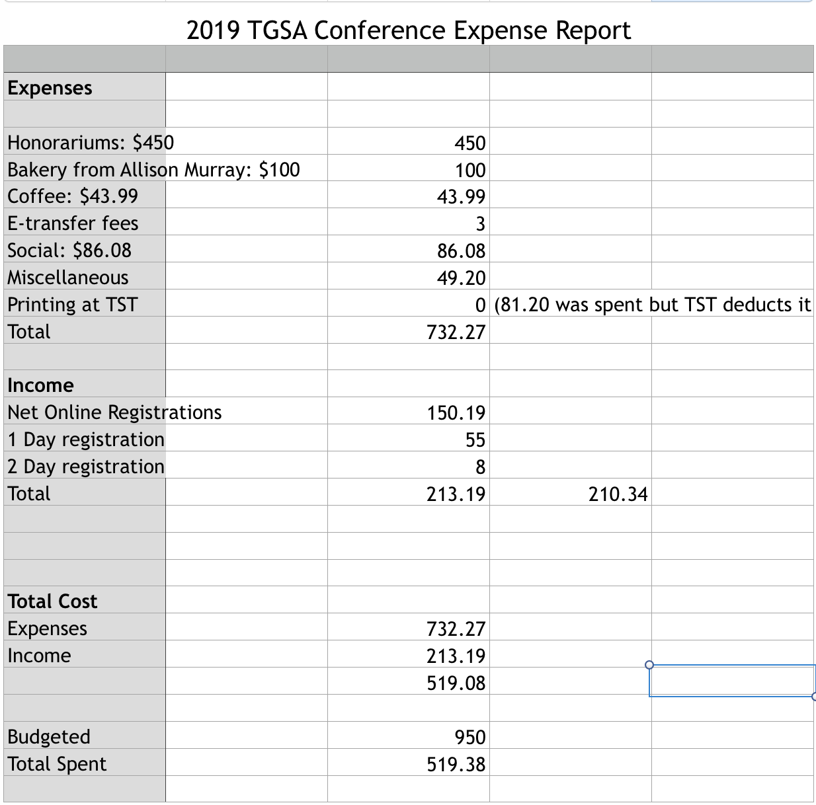

Current bank balance: $2981.58
Award winners for Winter conference: John Solheid and Caleb Henry

TST- Library Report

TST Director’s Search Advisory Committee

TST UTSU Director’s report

Non-voting Social Chair’s report

Facebook Policy Committee report

NEW BUSINESS:
- TGSA ELECTIONS: We have the following positions vacant as of April 10, 2019: Biblical rep, theological rep, MA rep, ThM rep, VP-External, Emmanuel Rep, Trinity Rep, and DMin rep. As of right now, we do not have a CRO either. I have contacted Ethan about being the CRO, but he has not responded back to my email.
- Copied from the policies document, here is the duties of the CRO:

E. Elections and Referenda (Constitution Section 3.2)

E.1 Returning Officer
E.1.1 Will be appointed by the TGSA Board at least six weeks before the election, with the motion recorded in the minutes to help gain access to voting.utoronto.ca (see https://www.studentlife.utoronto.ca/cld/voting-system-agreement for more details) or another secure online voting platform.
E.1.2 Will agree to be impartial and not seek an elected position or nominate anyone.
E.1.3 Will compile a list of positions coming open due to term limits and ask Board members for advance notice if they are resigning and/or seeking another position.
E.1.4 Will administer the nominations and elections according to the Policies and Procedures described below.
E.1.5 Will invite winning candidates to the next Board or General meeting after the election and present the results for ratification there.
E.1.6 Will announce the ratified results through the mailing list and update the list of Board members and their terms on the TGSA & TST websites.

E.2 Nominations
E.2.1 The nomination period should last at least 18 days and close at least two weeks before the meeting where the results will be ratified, subject to Board approval.
E.2.2 The Returning Officer will announce the open positions and nomination process on the mailing list three times, once before the nomination period and twice during it. They may also call for nominations through college bulletin boards, the TGSA website and social media pages, and in cohort classes, college meetings, or other public forums.
E.2.3 Candidates must be nominated by two of their peers, be willing to serve, and in the college, program, or concentration to be represented (if applicable). If it is unclear, the Returning Officer will ask potential candidates to declare their willingness to serve as well as their college, program, and concentration(s).
E.2.4 Once the nomination period ends, the Returning Officer will inform all the candidates of who is running and which positions are still vacant, giving multiply eligible candidates a brief opportunity to change the position they are seeking before the election without requiring additional nominations.

In the case of an election:
E.3.2.1 The Returning Officer will set a schedule for the general election so there are at least three weekdays for campaigning and three weekdays for voting, excluding school and religious holidays. They will first inform the candidates of the schedule and any rules for the election campaign, asking each for a statement of less than 1000 letters, including spaces. The Returning Officer will then announce the election, candidates, candidate statements, voting method and dates through the mailing list, TGSA website, and social media pages.
E.3.2.2 If one candidate asks, and a majority of the others agree, the Returning Officer will organize, announce, and moderate an Executive candidates’ forum.
E.3.2.3 The Returning Officer will work with voting.utoronto.ca or another secure online voting platform and the TST registrar to ensure a fair and secure online vote for every registered graduate student (Constitution Section 3.2). If a TGSA member is unable to vote, they can be emailed a ballot to print, complete, and seal in an envelope, to be counted once their eligibility and inability to vote is verified.
E.3.2.4 On the ballots, the positions should be in the same order as in the Constitution, and the option to randomize candidates should be checked.
E.3.2.5 Any ties will be resolved by a coin toss at the ratification meeting.

