Housekeeping:
- Emails Received:
  - Travel fund proposal: A student inquired about the possibility for a Research Travel fund to be created at TST/TGSA. He suggested that we can follow SGS’s format: http://www.sgs.utoronto.ca/currentstudents/Pages/SGS-Research-Travel-Grant.aspx
  - Email to Chris Stackaruk.
- Tuition fees: Please see the following email from Diane Henson

“CORMS received the data with respect to the 10% reduction in tuition fees for conjoint domestic programs for 2019-20 and the freeze for 2020-21. (They could only receive it or reduce further). I can confirm that the increases previously approved for non-conjoint domestic students both at the graduate and BD levels will remain in place. However, due to other time sensitive items on their agenda the conversation about International Fees (both conjoint and non-conjoint) did not take place. UofT has told me that they are not changing the International tuition fee increases for undergraduate students and as you know the tuition fees for most (but not all) of graduate programs were matched to their domestic fees due to other funding sources. This morning Dorcas sent out an email to CORMS with respect to International Fees. I will let you know the outcome when anything is confirmed.”

3. Update on SMC Rep
I (Liam) spoke with Mariia on Monday. She said that if we absolutely needed someone she would do it. I told her that that answer may come back to haunt her so she’s been duly warned. I really get the sense though that she doesn’t want to do this

Area Reps report:

Area and Rep’s Name | Content of report:
Biblical - Deborah
Pastoral - Beth Anne | -email Beth Anne about job
Systematics - Ethan
Historical - M.J.
Contextual - N/A
DMin - Barbara
MA - N/A
ThM - N/A

College Reps’ Report:

College and Rep’s name | Content of Report:
Emmanuel - Gina
Knox - Mike A. | I attended the Knox Theological Community Council meeting on Feb 14, a faculty-staff-student council that meets 2-3 times per year. I have a seat as Knox TGSA rep, to give our grad students a voice in institutional affairs. This group has no decision-making power, however, and I confess I’m less than confident that it makes a great difference. Just being honest . . .  I have let Knox basic degrees students know about the TGSA conference and encouraged any interested to attend. This could be a chance for more academically-inclined students to get a feel for grad studies.  This week I am enjoying very warm weather in Florida (Heaven’s Waiting Room). See you all soon at the Conference.
Regis - Mike R. | Regis has a few events coming up:  - Serpents and Dragons: Mary and Her Enemies in Mexican and Indian Art  March 20 @ 4:00 pm - 5:30 pm  - Crossroads of Theology Series: “Beautiful God: The Incarnation and the Arts”  March 25 @ 5:15 pm - 7:15 pm (Aimed at younger students, preregistration, meal provided)  - Redeeming the Anthropocene? – Fr. James Hanvey, SJ  March 26 @ 4:00 pm - 5:30 pm  - Finally, The Dignity of Young People in a Digital Age  March 28 @ 5:30 pm - March 29 @ 4:00 pm (registration is required, keynote by Pope Francis’ top advisor on the issue of clerical sexual abuse, Fr. Hans Zollner, SJ).  I haven’t noticed a consistent awareness about the conference among Regis students, I’ll do my best to get word out more in the next week, but could we have posters, etc to put up?
St. Mikes - N/A | St. Mikes has a two day conference on the Sexual Abuse Crisis in the Catholic Church happening this Thursday and Friday. It is free but you must pre-register.
Trinity - Robbie
Wycliffe - Carolyn | Wycliffe is hosting Carme Font speaking on “Hermeneutics of the Feminine: Recovering the Value of Women’s Religious Writings in the Long Reformation” on March 19, 4pm, Sheraton Hall, Wycliffe College. Everyone is welcome!

VP-Academic’s report

VP-Conference’s Report

- Regis, Sheptytsky and Emmanuel have both donated their space for free. This has freed up a fair bit of money in the budget which can now be used from things such as snacks (Carolyn is spearheading this) and the printing of our programs which we feel will give the conference a more professional look (Sam is spearheading this)
- After discussion we have decided that we will be providing the suggested amounts of honoraria to our speakers and worship leaders.
- Please sign up for both panels to chair and tasks to do day off. If anyone really wants to chair a panel and they are full up they can take mine
- Sam has organized a dedication and tribute to Zeppellin that will take place on the first morning of the conference. Saya Oriji a PhD student from Emmanuel will be giving a brief reflection.
- Ethan is working on getting SWAG bags. We may have an assembly party on Wednesday afternoon next week. Ya’ll are invited
- Website needs to be updated and for whatever reason it won’t let me do it but I hope its up and running by Wednesday night.
- We need money to buy snacks, print, etc and were unsure how to go about doing this? We also need a float for the day of.
- Do we charge profs to attend?
- Keep making Big Pushes at your colleges. Let’s make this the best conference ever.
- Correspondence Received Re Conference
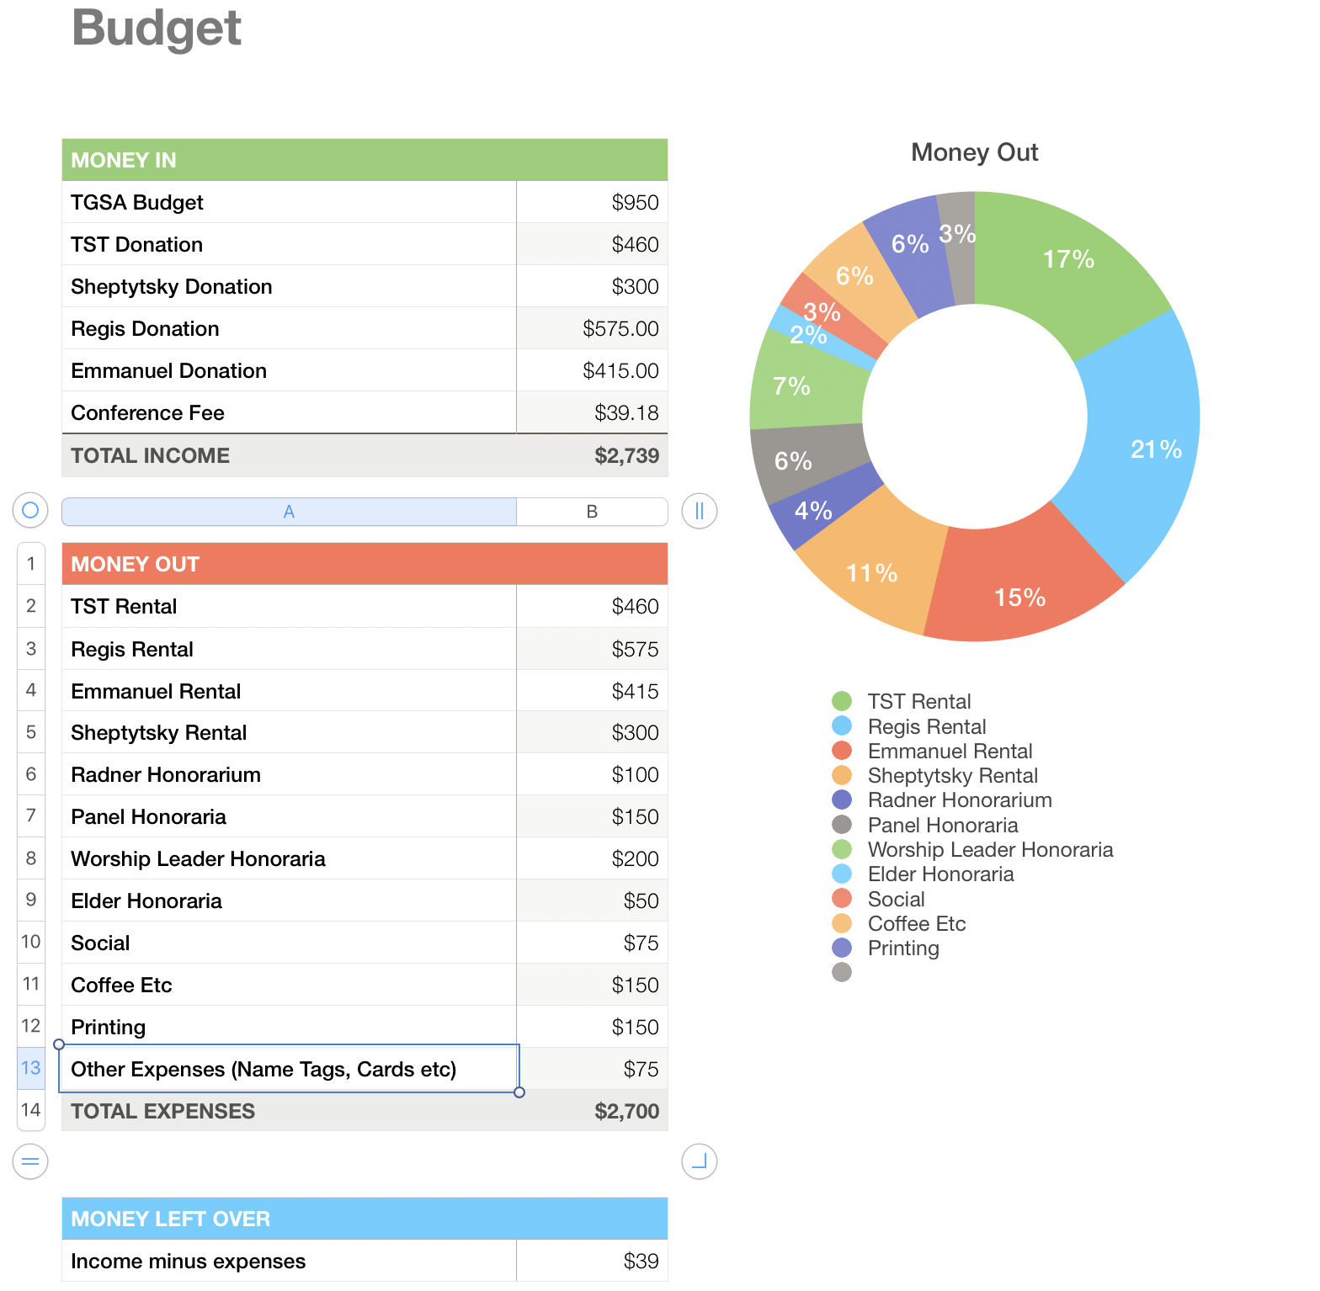

VP-External’s Report

Treasurer’s Report
Nothing new to report as no changes have been made.

TST- Library Report

TST Director’s Search Advisory Committee

TST UTSU Director’s report
Emergency meeting scheduled for tomorrow (March 14). Needham had to send his regrets since he is in class at the time. The meeting is in order to approve the 2019-2024 Strategic Plan. Find the cover sheet for the Plan here: https://www.boarddocs.com/can/utsu/Board.nsf/files/BA73ND025949/$file/2019-24_StrategicPlan_CoverMatter.pdf. Executive summary: three points. First, UTSU is moving into a new Student Commons, which has been in planning for some ten years. Second, the Student Choice Initiative by the Government of Ontario (https://news.ontario.ca/maesd/en/2019/01/government-for-the-people-to-lower-student-tuition-burden-by-10-per-cent.html) is a challenge to student funding in the province for everyone. President Boucher and the Executive Board oppose the legislation. It is likely that UTSU will have to do some campaigning to inform UofT students that they will have to vote to raise their own student fees, or else opt-in to paying fees, so that UTSU funding levels can be near their current level. Third, UTSU is trying to encourage as much student involvement as possible.

Non-voting Social Chair’s report
Thursday pub nights continue (March 14, 4:30pm, Duke of York Pub!). Needham has spoken with some TST students who have felt our normal social gatherings are not ideal for their interests, and is soliciting ideas for social events to be advertised around the community. Ideas: Snakes and Lattes, Bubble Tea, monthly ultimate frisbee or pickup games/volleyball, board game night or afternoon at TST.

Facebook Policy Committee report

NEW BUSINESS:
- TST Roundtable BBQ proposal: I [Fiona, as President] was invited to attend the TST Roundtable meeting earlier in March, as they were in the process of getting club recognition and Dorcas thought I might be of help in that discussion. In the meeting, one event that they are proposing is an End-of-Year BBQ, for April 17 at Trinity. They asked if TGSA could help promote their event, as ALL TST students are functionally members of the TST Roundtable, and as such invited to this BBQ. I suggested that maybe TGSA can join in on this; have our AGM earlier that day, then the BBQ can be our reception as well. The Trinity rep was very excited at this proposal and said that Trinity is also going to have a symposium that night following the BBQ, in hopes of attracting more people to join in on the festivities. I spoke to the execs about this proposal, and one concern that was brought up is that technically we had agreed to have our AGM on April 10th. As such I have come up with a couple of options in response to this proposal:
  - YES, we would like to move our AGM date to April 17th and combine our event with the TST Roundtable’s BBQ
  - NO, we would like to have our AGM on April 10th, and are open to the Roundtable moving their event up
  - NO, we would like to have our AGM on April 10th, and our reception separate from the TST Roundtable event.

