Area Reps’ Report:

Biblical - Deborah

Pastoral - N/A

Systematics - Ethan: We had our daytime formal discussion on Thursday, January 17th in Regis’ atrium at 10am. We discussed the role of the Bible in the particular context of systematic theology, as that offered a nice opportunity to remind everyone to be submitting proposals for the TGSA Conference. We had 8 in attendance, as well as a handful of regrets, which is an upward trend. The discussion was lively, respectful, and enjoyable. Our next event will be the social evening on Monday, January 28th at 7:30pm at The Lab. The informal subject of discussion will be Theology and Superheroes/Superhero movies. Should be light and fun unless I bring out my Communist Critique guns and start talking about how fundamentally conservative the superhero trope is.

Historical - M.J.
No Report

Contextual - N/A

DMin - Barbara: Efforts were made to reach out to DMin students (through the DMin portal on Quercus, as well through the DMin Director and Administration) so that they are aware of having a TGSA representative and of being able to contact me should they have any items of concern or to share. As of yet, no one has contacted me and there is nothing new to report.

MA - N/A

ThM - N/A

College Reps’ Reports:

Emmanuel - Gina

Knox - Mike

Happy to report that Knox students now have a dedicated grad study space, at least a temporary spot for this semester until more permanent arrangements can be made. As I’ve mentioned before, I believe our colleges should work towards a more equitable grad student experience. There should not be wide disparities in funding, study space and TA/RA opportunities between students in the same program just because they’re registered in different colleges. This reasoning motivated Knox to fix this problem sooner rather than later, as we were the only college without some kind of dedicated grad study space. (They just needed someone to point that fact out to them!)

Nothing going on at Knox in the next little while that would be of interest to the wider TGSA community.

Regis - Liam

- The Lonergan Research Institute is holding one of their Graduate Seminars on Friday (Jan. 25). All are welcome. John Dadosky is presenting “Further Along the Fourth Stage of Meaning: Lonergan, Alterity and ‘Genuine Religion.” Jonathan Bernier, the institute’s director is the respondent. We have several public events coming up at Regis College. On January 31st, Zane Chu, a PhD Candidate at Regis, is giving a lecture on Thomas Aquinas’ Theology of Love: Crossroads of Theology Series. This is designed for undergraduate students who may be interested in studying theology and will be followed a reception. On February 7th Prof Gemma Simmonds, CJ from the Margaret Beaufort Institute of Theology in Cambridge is presenting a Faith Issues Today Lecture entitled “A View from the (Other) Bridge: a Woman’s Perspective on Ignatian Spirituality. It’s co-sponsored by the Loretto Sisters. On February 11th the Msgr. John Mary Fraser Centre for Practical Theology is presenting a lecture entitled “Early Jesuit Engagement with the Qur’an: Questions, Answers and a Few Puzzles” by Dr. Paul Shore from the University of Regina. On February 13th, two days later, The Msgr. John Mary Fraser Centre for Practical Theology is going to be officially opened. This will coincide with the inaugural Scarboro Missions Lecture in Interreligious Dialogue. The lecture entitled “Lakota and Christian Interreligious Dialogue: Questions Surrounding the Life, Teachings, and Influence of Nick Black Elk” and will be given by Prof. Michael Stoeber the Scarboro Missions Chair in Interreligious Dialogue. The respondents are Jonathan Hamilton Diabo, the Director of Indigenous Initiative at the University of Toronto and Dr. John Dadosky from Regis College. Dr. Pamela Couture from Emmanuel College will be moderating the event. On February 26th the Annual Royackers lecture to honour the memory of Fr. Martin Royackers, SJ, a Jesuit from the English Canada province who was martyred (murdered) in Jamaica will be presented by Human Rights and Peace Activist Miko Peled. It is entitled Justice, Freedom, and Equality: Keys to the Peace in the Holy Land. All of these events are free but require RSVP which can be done on the Regis Website.
- I was asked by a student about what the policy was on bringing an advocate to meetings. While I don’t know the official TST policy, this did make me remember that we have an advocacy officer who could easily serve this role if it is allowed. Perhaps once we figure out if this is allowed, or even if it isn’t, we should send out an email to the general membership to remind them that such a position exists.

St. Mike’s - N/A

Trinity - Robbie
No report. Rev. Dr. Margaret Fleck died this month, namesake for the chair in Anglican studies at Trinity College.

Wycliffe - Carolyn

There are a couple of events happening at Wycliffe this Friday (Jan. 25): The Toronto Christian Scholars' Symposium is taking place at Wycliffe from 10:00am to 3:30pm, and “What Does it Mean to be Human,” a discussion//debate about artificial intelligence, will be held at Convocation Hall from 7:00pm to 10:00pm. Wycliffe’s annual Preaching Day will be taking place on February 19, focusing on preaching from the gospel of John. Everyone is welcome. All of these are ticketed events, with reduced prices for students. You can find more info about all of these events on Facebook or Eventbrite.

VP-Academic Report – Emma
Wednesday, January 23th, 2019

Academic Council — Monday, December 21st, 2019

- UTQAP (University of Toronto Quality Assurance Process)
  - The review will take place in Winter 2020 although a specific date is yet to be set, dependent on the availability of the reviewers. This means that the self-evaluation will need to be finalized in Fall 2019.
  - Updates forthcoming
- MTS stream in Theology, Spirituality, and the Arts
  - No new details
- NAIITS: An Indigenous Learning Community (formerly North American Institute for Indigenous Theological Studies)
  - No new details
- Graduate Status for Professional Teaching Staff
  - No new details
- Post-Baccalaureate in Theology and Interreligious Engagement
  - No new details
- Research on Human Subjects in Basic Degree Courses
  - No new details
- Report from Graduate Studies Council
  - 98 fully completed graduate applications
  - Number of applications is up from previous years
- 2016: ~70 applications
- 2017: ~60 applications
- 2018: ~80 applications
  - Updates forthcoming

UPCOMING MEETINGS:
- Academic Council Meeting on February 25th, 2019
- Graduate Studies Council Meeting on March 5th, 2019

Questions/Follow-Up:
- Follow-up with UTQAP
- Follow-up with MTS Stream
- Follow-up with NAIITS
- Follow-up with Graduate Status for Professional Teaching Staff
- Follow-up with Post-Baccalaureate in Theology and Interreligious Engagement
- Follow-up with Research on Human Subjects in Basic Degree Courses
- Follow-up with TST graduate applications

VP-Conference Report - Liam

So there is a lot of ground to cover this month, which is a good thing because it means that things are moving forward. We have received a few abstracts and I have been told to expect more. I feel that since most people tend to submit at the deadline we’ll see a big push next week. If not the committee will discuss extending the deadline as was done last year. Please continue to promote it and to clarify to student’s who are wondering that this conference is about engagement with scripture and not, strictly speaking, a biblical studies conference. (Although biblical studies papers are welcome) We are still looking for a fifth member of the committee. Given that the committee is currently three men and one woman, a woman would be preferred to provide a more equal voice. The TST building and St. Sophia Chapel have both been booked for the conference. Both spaces were graciously donated free of charge by TST and MASI respectively. Both will be thanked at the conference. The Committee thinks that it is a good idea, however, to have the panel discussion and keynote address at member colleges to accomodate more people. We have suggested Regis College and Emmanuel College as they are close by the TST building. Liam is looking into booking them. We have discussed honorariums for the speakers and presiders which will be reflected in the attached budget. We also discussed having coffee, tea, etc which will also be reflected in the budget. This budget is our most conservative estimate thus far, however, it should be noted that it may either increase or decrease. I will also note that it does not include the estimation of the cost of tickets as that will be dependent on the number of people and eventbrites fees. I suggest we do not include this in the budget for the conference but instead apply the funds earned to other activities afterwards. Andrew Wesley is going to be contacted regarding the opening ceremonies and land acknowledgment. We thought it best to ask him what to do as opposed to suggesting something. So once we hear back from him we will have a better idea of what that will look like. We are still waiting to hear from Paul Scott Wilson. The social the first night will be held at Future’s Bistro Cafe. This is an accessible cafe that is a half and hour walk or 15-20 minute subway from TST. We chose this location because it has affordable food and is not a bar, thus people who don’t like to go to bars can still be included. Future’s also allows people who do wish to drink to partake if they choose. It is also close to both The Lab and Snakes and Lattes providing both bar and non-bar related options for those who may wish to continue socializing. We have a few proposals for the topic of the panel session which we would like the board to discuss and vote on. As one topic (or in some cases two topics) are being put together by each member of the committee, I am presenting them anonymously in the the order received.
- How could/can women use/interpret the Bible as authoritative in a liberation perspective?
- Is it possible for a theologian to achieve a second naïveté concerning scripture while maintaining an adequate hermeneutic of suspicion?
- Bearing in mind the theological distinction between Christ and the Church, which would you feel the Bible more closely aligns with the Word of God or the witness of the community of faith?
- Is the Bible active or passive?
- What effect does document dating and/or textual criticism have on theological conclusions?
- Is the Bible principally a source for theology or a regulative boundary for theology?
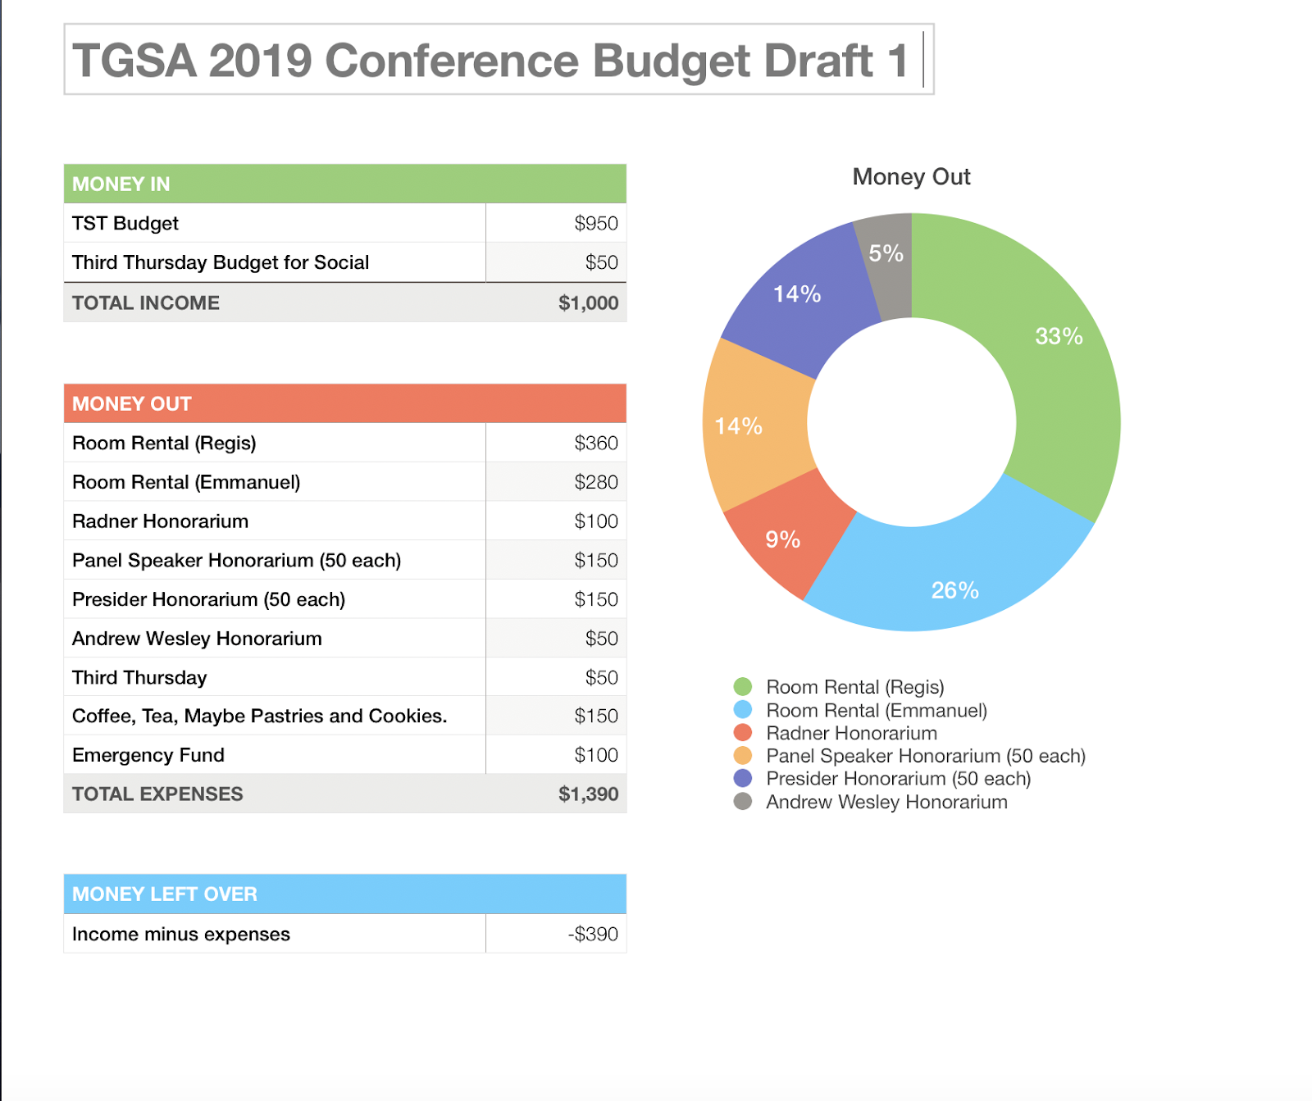

VP - External - Ethan

Nothing to report.

Treasurer's Report - Leanne
So far, we have saved $560.08 between the garden party/BBQ and not doing any PD seminars in October and January as had been planned at the start of the year. The budget was also made for $4250 and we received $4874.85 for a surplus of $624.85.
Between our savings and the surplus-- $1,184.93.
An additional line item I have added to the budget is bank fees. Each month we are charged $2.50, for a total of $30 per year. Each e-transfer is also $1.50. A healthy budget for this line item would be $75, I think.

With that subtraction from the total, we are left with $1,109.93 to determine its usage.

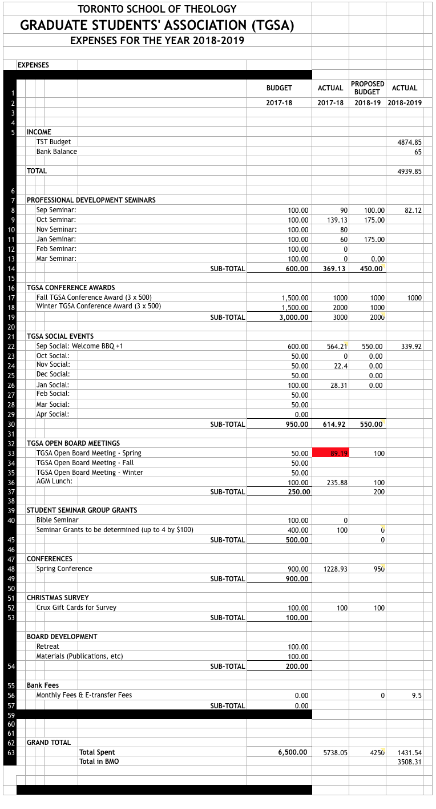

Library Council’s Report

Meeting is to be held in February. I have received one request to take the item of accessibility to the committee with a suggestion by the same person who made the request.

TST- Director’s Search Report
The committee met on January 17, 2019, and applications are coming in.

New Business

Inquiries received:
- Cohort for Mothers with young children: This was brought to my attention by a PhD student at Wycliffe. She is also a mother with young children, and was wondering if we can help form “some kind of cohort of doctoral students who were also mothers of young children (aged 5 and under) in order to share, support, and encourage each other during this challenging road” (taken from her email received on December 6). I told her this is an interesting idea and that I would bring it to the Board for further discussion.
- Lenten activity: This is an activity suggested by a PhD student, and it is basically a re-enactment of the trial of Jesus under Canadian law, based on the claims and actions he made in the different Gospels. He suggested getting a group of lawyers, and even a judge to play those roles, but I wonder if it would be easier, that is if we decide to help organize this event, if those roles can be played by TST students.
- Regalia: This was brought to my attention by a PhD student from Knox. She was interested in participating in the design process for the new conjoint PhD convocation regalia. However, the answers she has been getting were not helpful and vague. I sent an email to David about this, and he got back to me recently. He asked the Director, and she told him that , “all design takes place at the college-level” (taken from his email received on December 11). As such, the student will have to speak with either her Dean/Principal about this.

TGSA Merch:
I [Liam] spoke to my colleague at CLAMPS and she told me that they dealt with a company called Artik Toronto. They have a minimum number of 100 lanyards per order so I don’t think they’ll suit our business needs. I found a website called customlanyard.ca that sells them in quantities of 10 and 20. We could look at that.

Fall Travel Grants:

The 2018 Fall TGSA conference award winners are::

Eser Kim
Sheng Ping Guo

I [Fiona] clarified the process with David Wagschall, notified the winners, and have forwarded their emails and names to Leanne for cheque distributions.
Room Bookings:

I [Fiona] have spoken to Colleen about the lack of willingness on the parts of the Colleges to rent space for TGSA at a lower price/free. She suggested that she would take it up with CORMS, and I should send her a proposed rotation schedule for the College heads. The schedule is based on past interactions with different colleges, such as hosting workshops, BBQ, etc. As our main events are the SSHRC pd seminar, Welcome Back BBQ, and the annual conference, I only included those events. I think all the other miscellaneous events can be held at TST, as it may attract a smaller crowd. Furthermore, as the non-federated colleges seem to have a more flexible catering situation, I decided that those colleges will be best suited for the Welcome (Back) event. And the federated colleges, which technically has access to more physical space, may be better suited for hosting the Conference. As such, the proposed schedule is as follows:

DATE | FUNCTION | COLLEGE
Fall 2019 | SSHRC PD Seminar | TST
Fall 2019 | TGSA Welcome (Back) Gathering | Regis
Spring 2020 | TGSA Conference | St. Mike’s
Fall 2020 | SSHRC PD Seminar | TST
Fall 2020 | TGSA Welcome (Back) Gathering | Wycliffe
Spring 2021 | TGSA Conference | Trinity
Fall 2021 | SSHRC PD Seminar | TST
Fall 2021 | TGSA Welcome (Back) Gathering | Knox
Spring 2022 | TGSA Conference | Emmanuel

Colleen will keep me updated as to whether this rotation schedule is approved or not by the College heads.

Update on Wednesday classes:
Notified David of the existence of Wednesday afternoon classes, and he will talk to the GCTS director, Colleen, about it.

Facebook Policy:
You all may be familiar with the issue last year where a member of the greater TGSA community was posting constantly and on a matter that, while interesting, was not TGSA-related. I spoke to Robyn Boere, the main author of our current policies, and she informed me that actually we don't have any policies regarding the public's use of our Facebook page. The policies we have currently govern our behaviour on Facebook as Board members, but not about the types of posts that can be made on Facebook and the frequency of those posts by non-Board members. As such, I am hoping to have a policy created as soon as possible. This policy need not be long. It can literally be two-three lines. So I come to you with the following proposal, if you all agree that this is something we should remedy: (a) have a committee commissioned to write this policy; (b) have this policy presented at the February meeting, where it will be voted on.

TGSA Social Chair:

This year, we opted to not plan any Social events as area reps can organize such events for their own constituents, and because there was a poor turnout rate in the past two years. However, I’ve noticed that Sam Needham, our UTSU director, has created networks with many different groups of persons, and has been informally organizing social events already. As such I thought that he would be an excellent person to be the designated person to organize such events for TGSA as a whole. That is not to say that Sam will have to do all the work, but he would be the brains behind the operation. For example, he will decide on a date for a particular social event and the location of the event. Other TGSA members still have to pitch in, in terms of promotion, participation at the event, and possibly setting up. I spoke to Sam about this possibility and he was definitely open to it.

Besides these informal social events, Sam as the social chair would also be the overseer of the Welcome (back) event. If CORMS approves of the proposed rotation schedule (see above), then his role in planning this event will be: to confirm that the location is booked for the event, decide on the type of food that will be served, purchase/order said food and drinks, organize food and drink delivery to event, and keep receipts of all purchases (which will be handed over to Leanne).

