APPENDIX: Submitted Written Reports

Reports from Board and Standing Committees

AREA REPS’ REPORTS:

Pastoral - Amy

I have had some difficulty getting everyone’s email addresses from the sign up sheet at the bbq, so I haven’t been able to send out a welcome email. I tried doing it manually, and unfortunately there are so many students with the same names at U of T I can’t tell who is who. Fiona is aware of this and she also encountered some difficulties getting emails. Has anyone else had this happen? Any work-arounds known?

Other than that things are good. No concerns to report at this time.

Systematics - Ethan

The folks who signed up on the clipboard for the Systematic Theology group received an email from me last Friday (Oct. 5th) for introduction and organization purposes. I also created a Facebook page (https://www.facebook.com/groups/899304923592293/) which all interested parties are welcome and encouraged to join. We will be having a first (more social) meeting sometime next week TBD. My intention is to hold gatherings every 2 weeks--once a month we will have a more organized discussion-focus with a pre-determined topic (these meetings will probably be during the day somewhere on or near campus, to facilitate participation), and then in the every-other-2-weeks we’ll hold a less-formal/more-social get together.

DMin - Barbara

The current DMin director is in the process of reviewing and updating the various components of the program, along with their description in the DMin Handbook, making sure there is clarity and consistency and that students and teachers have the necessary information and technical support to complete their requirements. An issue that arouse with a DMin student not being able to move forward with the REB (Research Ethics Board) due to technical problems (lack of access to codes), has been resolved.

COLLEGE REPS’ REPORTS:

Regis - Liam
On September 27, Regis College hosted an event in order to celebrate the new Jesuit province of Canada. It consisted of a mass presided over by the Very Rev Eric Orland, SJ, the new provincial, and deaconed by, GD student, Rev Mr Adam Hincks, SJ, a dinner, and a panel discussion on the importance of the bilingual province with Rev Michael Knox, SJ, a Regis lecturer, Rev André Brouillette, SJ, and Sr Nancy Sheridan, SASV. On October 6, the Student Council lead a pilgrimage for students to the Canadian Martyrs Shrine that included opportunities for prayer, visits with the local Jesuit community and a talk/tour with Rev Michael Knox, SJ, the Shrine’s director. The Lonergan Research Institute, which is based out of Regis, is having their first graduate seminar on October 18. The main speaker will be Prof Michael Vertin of the University of St. Michael’s College. He will also be delivering the Annual Lonergan Lecture on the evening of October 19, the theme for which is Self-Appropriation and Ecumenical Dialogue: A Hypothesis. Rev Edmund Lo, SJ, a recent GD graduate has been named the National Coordinator of the Pope’s Worldwide Prayer Network.

Respectfully submitted by

Liam Farrer
TGSA Regis College Representative

Trinity - Robbie

To my knowledge, there is nothing major to report from Trinity College. Thank you.

Wycliffe - Carolyn

Hi friends, apologies for my continued absence. I hope to make it to a meeting one of these days… :/

There are a few upcoming events at Wycliffe, to which all are welcome:
October 19: Wycliffe’s semi-annual Scripture and Theology Colloquium. Theme is “Martyrdom and its Scriptural Shape”
October 20: CATA (Canadian American Theological Association) conference. Theme is “Peace and Violence in Scripture and Theology”
There is a fee for both events - student pricing and combined tickets for both events are available: https://www.facebook.com/events/271691930083176/
October 26: Pub Theology https://www.facebook.com/events/738372919827890/

Dr. Sarah Coakley’s visit was well received and her lecture was well attended by students across TST. The lecture will be put on youtube very soon, for those who weren’t able to attend.

Lastly, the Wycliffe Graduate Society meets every Thursday at 1. Unfortunately this makes a conflict with the BYOL gatherings. Would it be possible to have the BYOL on another day?

Respectfully submitted,
Carolyn

VP-ACADEMIC REPORT

Academic Council Meeting on September 24th, 2018

- There will be a new MTS stream in Theology, Spirituality, and the Arts. More details will be available at the next AC meeting.
- NAIITS (formerly Native American Institute for Indigenous Theological Studies) has officially become an affiliate member of TST.
  - Follow-up
- The policy has been approved for the Graduate Status for Professional Teaching Staff. (This means that professionals who qualify will be able to teach at the graduate level.)
  - Follow-up
- There is a new Post-doctoral Fellowship in Christian-Jewish relations.

Graduate Studies Council Meeting on October 2nd, 2018

- The ThD and PhD (USMC) degrees will be closed. There will be accommodation for students either through “terminal reinstatement” or the option to transfer into the ThM II degree.
  - Follow-up
- The TST AAR/SBL Reception will be held on Saturday, Nov 17th at 9:00-10:30 pm at the Savory Room of the Sheraton Downtown (on the Majestic Level of the I.M. Pei Tower—2 levels below the lobby).
- The TST search committee was approved to find the new TST director. The search committee includes heads of colleges, a person approved by the Provost’s Office, a TGSA representative, etc.
- There is a new option for the general examinations. You now have the option between a 3-4 hour sit-down exam or a 24 hour take-home exam.
- The admission statistics are in for the 2018 Cohort:

Total PhD: 31
- Female: 14
- Male: 17
- Domestic: 18
  - Female: 6
  - Male: 12
- International: 13
  - Female: 8
  - Male: 5

Total MA: 11
- Female: 5
- Male: 6
- Domestic: 7
  - Female: 3
  - Male: 4
- International: 4
  - Female: 2
  - Male: 2

Total ThM: 7
- Female: 0
- Male: 7
- Domestic: 4
- International: 3

Grand Total: 49
- Female: 19
- Male: 30

VP-CONFERENCE REPORT

5 October 2018
Conference Committee Report

Part I)

The conference committee has not met since the board meeting on 26 September 2018.

Part II)

During the TGSA Board Executive Meeting on 5 October 2018, Fiona informed the Board that the General Secretary of the Canadian Council of Churches had offered TGSA, through her, a large amount of funding. One of the options for the allocation of that funding was to host a national conference. Fiona informed them that such as conference would have to take place in 2020 and said that they seemed amenable to that option. After brief discussion the Executive Board decided that this was the best option for TGSA moving forward and I was commissioned to write the attached proposal as well as letter to the General Secretary for discussion at our October meeting.
Respectfully submitted by
Liam Farrer
TGSA VP Conferences

Att: 2020 Conference Proposal, Letter to Mr Peter Noteboom

Liam A. Farrer
47 Queen’s Park Cres E
Toronto, ON M5S 2C3
647-461-3418
liam.farrer@mail.utoronto.ca

October 5, 2018
Peter Noteboom
General Secretary, Canadian Council of Churches
47 Queen’s Park Cres E
Toronto, ON M5S 2C3

Dear Mr. Noteboom,

My name is Liam Farrer, and I am the Vice President Conferences for the Toronto School of Theology Graduate Student’s Association Board (TGSA). I am writing to you with regards to your offer of funding to allow TGSA to engage with graduate students on a national level. After reviewing the options which your office suggested to us, we believe that the best one for our board would be to use the funds to host a conference in the spring of 2020. We would select the theme of the conference at a later date, in consultation with your office. If you need any further information or clarification please do not hesitate to contact me using the information provided above. We hope that this decision is amenable to you and eagerly look forward both to your response and to working with the Canadian Council of Churches.
Sincerely yours,

Liam A. Farrer
Vice President Conferences and Regis College Representative
Toronto School of Theology Graduate Students Association

5 October 2018

2020 Conference Proposal

During a recent meeting with the General Secretary of the Canadian Council of Churches, here after CCC, our president was offered a large sum of money from the aforementioned body upon condition that these funds be used to further promote graduate student engagement in conferences at the domestic level. Upon consideration of the proposals put forth by the CCC and the recommendations of the executive board, I propose the following two resolutions for discussion and to be voted on by the board during our meeting of 10 October 2018 :

1) That said funds are used by TGSA’s board in 2020 to host a national, potentially international conference, on a yet to be decided theme.
2) That the attached letter be sent to the General Secretary of the Canadian Council of Churches.
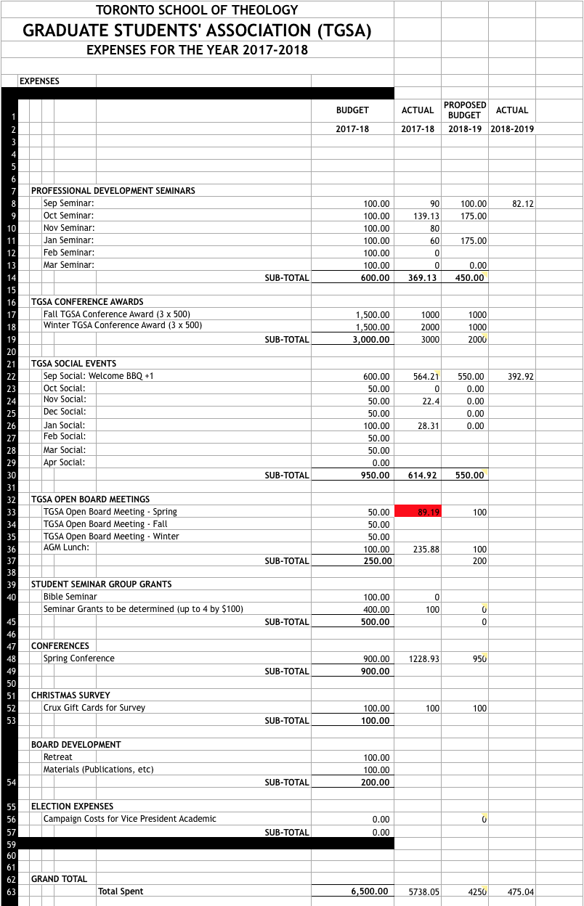

TREASURER’S REPORT
We had two events in September for which budgetary resources were expended: Welcome Back BBQ and the SSHRC/OGS Grant Writing Workshop.

Budgeted for these two events was a combined $650. We spent $475.04. Great job to all of putting on excellent events while coming in under budget.

A copy of our current budget is provided, showing our budget/actual for last year, as well as this year. So far, so good. Keep it up!

I am still in process of gaining access to the bank accounts. Once that takes place I can reimburse the submitted receipts and also track our income, so I hope to have greater detail in November.

NEW BUSINESS

Dear Colleagues,
Since I won’t be there for the first half of the meeting, I thought that I should explain the piece of old business that I’m supposed to present at the meetings start in writing as I cannot in person. So for the sake of context during our orientation an MA student approached us at the sign up table and expressed some frustration that A) their topic did not have its own representative and, upon finding out that this likely wouldn’t be changed given that this would set a precedent for every sub-area to have it’s own representative that, B) the term TGSA was using was Pastoral and not Practical. As time has passed and I’ve thought about the issue more, I have come to believe that given that the industry standard seems to be moving from the use of the term pastoral to the use of the term practical it would make sense for TGSA to follow suit.
Therefore, I resolve that on our meeting of October 10, 2018, the TGSA Board change the title of the Pastoral Representative position to Practical Representative, and amend the Toronto School of Theology Graduate Students Association Policies and Procedures Section D Subsection 10 from:

D.10 Concentration Representatives Members who hold the following seats (Bible, History, Theology, Pastoral, Contextual) will follow the policies and procedures that apply to External Committee Representatives. Further, concentration representatives are responsible for updating the Board, and, by extension, TGSA members of professional development opportunities specific to their area such as conferences, call for papers, fellowships, job openings, and funding opportunities. Concentration representatives, should also work to connect students in their concentration with colleagues from across the TST colleges.

to
D.10 Concentration Representatives Members who hold the following seats (Bible, History, Theology, Practical, Contextual) will follow the policies and procedures that apply to External Committee Representatives. Further, concentration representatives are responsible for updating the Board, and, by extension, TGSA members of professional development opportunities specific to their area such as conferences, call for papers, fellowships, job openings, and funding opportunities. Concentration representatives, should also work to connect students in their concentration with colleagues from across the TST colleges.

with the understanding that all changes apply to the name only and that the incumbent shall retain her position under the new title.
Yours Faithfully,
Liam Farrer
TGSA Vice President Conferences and Regis College Representative.

